Avail Recovery Solutions
Environmental Health and Safety Policy

- Avail Recovery Solutions has a zero tolerance landfill policy for the electronic waste we handle and will protect the environment by maintaining the highest possible standards of recycling.

- Avail Recovery Solutions is committed to the prevention of pollution, the provision of a safe and healthy work environment, the elimination of hazards and reduction of OH&S risks and the prevention of injury and ill health.

- Avail Recovery Solutions is committed to meeting customer requirements.

- Avail Recovery Solutions is committed to managing used and end of life electronic equipment based on a reuse, refurbishment, recovery, disposal (RRD) hierarchy including onsite and downstream materials management throughout the recycling chain.

- Avail Recovery Solutions is committed to managing Focus Materials throughout the recycling chain to final disposition with due diligence to protect our environment.

- Avail Recovery Solutions is committed to continuous improvement achieved through monitoring of objectives and targets and rigorous evaluation of our management system.

- Avail Recovery Solutions is committed to complying with all legal and other requirements.

- Avail Recovery Solutions is committed to communicating and reinforcing this policy throughout our company, as well as, to our customers, our suppliers and to the public.

We recognize that the responsibilities for environment, health & safety and security are shared, requiring cooperation, not only between employees and their supervisors, but among and between all those who assume the various roles within the company.

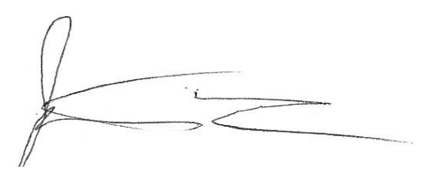
Avail Recovery Solutions will continually improve the EH&S system and performance. This will include the setting of EH&S goals, taking into consideration our EH&S aspects and impacts from our business, financial, operational and legal requirements as well as the views of interested parties.

(Signature)
President
Date 2/18/2020

Document Revision History
Rev. | Description of Change | Date | By
A | New | 12/1/17 | E. Hartigan
B | Revised to conform to ISO 45001:2018 commitments | 2/18/20 | - Gonzalez

